**Project Planning Phase**

**Project Planning (Product Backlog, Sprint Planning, Stories, Story points)**

|  |  |
| --- | --- |
| **Date** | 06\10\2022 |
| **Team ID** | PNT2022TMID21549 |
| **Project Name** | Project – Global Sales Data Analytics |
| **Maximum Marks** | 8 Marks |

**Product Backlog, Sprint Schedule, and Estimation (4 Marks)**

Use the below template to create product backlog and sprint schedule

|  |  |  |  |  |  |  |
| --- | --- | --- | --- | --- | --- | --- |
| **Sprint** | **Functional**  **Requirement (Epic)** | **User Story Number** | **User Story / Task** | **Story Points** | **Priority** | **Team Members** |
| Sprint-1 | Data Collection | USN-1 | Collect the dataset or Create the dataset  . | 2 | High | Shamin thres,  Priyanka s,  Sharon rose,  Shruti R |
| Sprint-2 | Image | USN-2 | Importing the required libraries and Loading | 1 | High |  |
|  | Preprocessing |  | Train data and Test data .  Quantifying images with Label Encoding |  |  | Shamin thres,  Priyanka s,  Sharon rose,  Shruti R |
| Sprint-3 | Model Building | USN-3 | Training the model,Testing the model ,Model | 2 | Low |  |
|  |  |  | Evaluation, Saving the model |  |  | Shamin thres,  Priyanka s,  Sharon rose,  Shruti R |
| Sprint-4 | Application Building | USN-4 | Create an HTML file and and Build Python | 2 | Medium | Shamin thres |
|  |  |  | Code |  |  | Priyanka s,  Sharon rose,  Shruti R |

**Project Tracker, Velocity & Burndown Chart: (4 Marks)**

|  |  |  |  |  |  |  |
| --- | --- | --- | --- | --- | --- | --- |
| **Sprint** | **Total Story Points** | **Duration** | **Sprint Start Date** | **Sprint End Date (Planned)** | **Story Points**  **Completed (as on**  **Planned End Date)** | **Sprint Release Date (Actual)** |
| Sprint-1 | 20 | 6 Days | 24 Oct 2022 | 29 Oct 2022 | 10 |  |
| Sprint-2 | 20 | 6 Days | 31 Oct 2022 | 05 Nov 2022 | 0 |  |
| Sprint-3 | 20 | 6 Days | 07 Nov 2022 | 12 Nov 2022 | 0 |  |
| Sprint-4 | 20 | 6 Days | 14 Nov 2022 | 19 Nov 2022 | 0 |  |

**Velocity:**

Imagine we have a 10-day sprint duration, and the velocity of the team is 20 (points per sprint). Let’s calculate the team’s average velocity (AV) per iteration unit (story points per day)

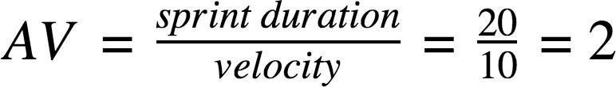

**Burn Down Chart:**

A burn down chart is a graphical representation of work left to do versus time. It is often used in agile [software development me](https://www.visual-paradigm.com/scrum/what-is-agile-software-development/)thodologies such as [Scrum.](https://www.visual-paradigm.com/scrum/scrum-in-3-minutes/) However, burn down charts can be applied to any project containing measurable progress over time.

Expected Burndown Chart:

Burndown Chart

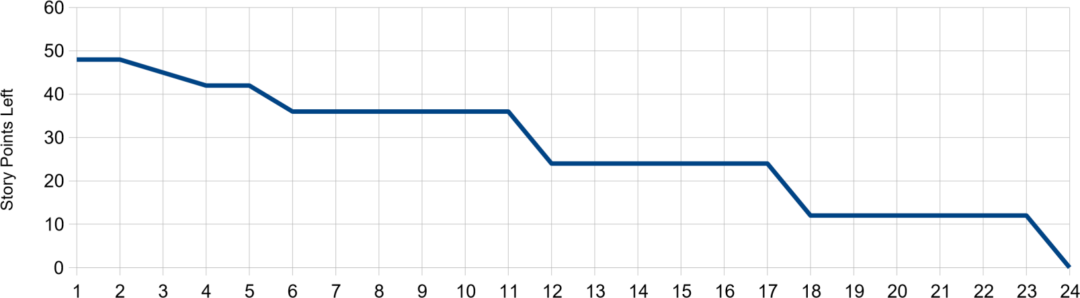

Day